GAME2005- Assignment 1

Chris Tulip - 100 818 050

A)

$θ= {\frac{1}{2}\sin^{-1}( (g * x) / {V_{i}^{2}}_{})}^{}$

$θ= {\frac{1}{2}\sin^{-1}( (9.8 * 485) / {{95}_{}^{2}}_{})}^{}$

$θ= {\frac{1}{2}\sin^{-1}( 0.527 )}^{}$

$θ= {\frac{1}{2}( 31.8 )}^{}$

$θ= {15.9}^{}$

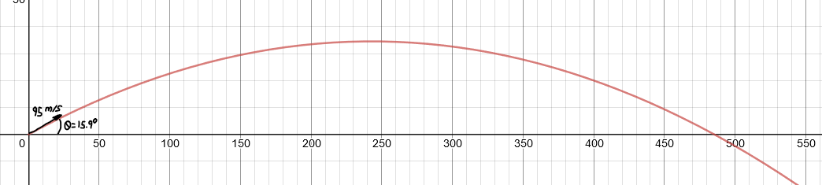

B)

For this part were going to make the angle 45° because that’s the angle that yields the furthest distance

$R = V² * sin( 2θ ) / g$

$R = 95² * sin( 2 * 45 ) / 9.8$

$R = 9025 * 1 / 9.8$

$R = 9025 / 9.8$

$R = 920.9$

